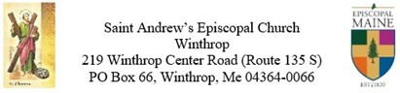
The 21st Sunday after Pentecost
October 17, 2021
Morning Prayer Rite II
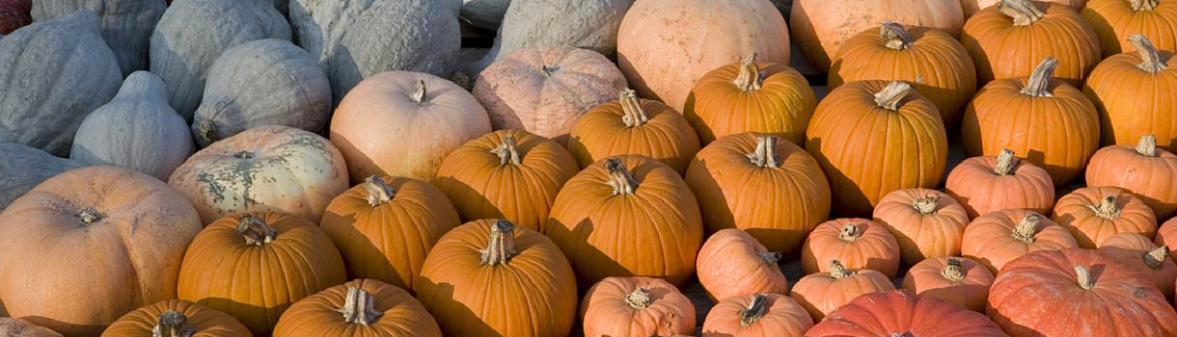

Ruth Ann Prelude

Tina Welcoming
Opening Hymn Hymnal #493 O for a thousand tongues to sing
Opening Sentences page 78 BCP (Psalm 122:1)
Confession of Sin page 79 BCP (Dearly Beloved…)

Amma Susan Absolution page 80 BCP

Edie Invitatory and Psalter page 80-81 BCP (The mercy of the Lord...)
Canticle Jubilate page 82 BCP
Glory to the Father
Psalm 91:9-16 page 720 BCP (We will read responsively by whole verse)

Lesson 1 Isiah 53:4-12

Tina Canticle 9 The First Song of Isaiah page 86 BCP
Glory to the Father

Lesson 2 Hebrews 5:1-10

Edie Canticle 21 You are God page 89 BCP
Glory to the Father
Hymn Before the Gospel Hymnal # 562 Onward Christian soldiers

Amma Susan Gospel Reading Mark 10:35-45

Bill Nave The Sermon

Edie Apostles Creed page 96 BCP
The Prayers page 97 BCP

Intercessor Suffrages A page 97 BCP
Saint Andrews Prayer List
Diocesan Prayer List

Tina Collect of the Day Proper 24 page 235 BCP
Collects (Collect for Sunday page 98 BCP and Collect for Grace page 100 BCP)

Edie Peace

Tina Bird House

Edie Offertory Hymn Hymnal #Lord, you give the great commission
Offertory Sentence

Ruth Ann Doxology

Tina The General Thanksgiving page 101 BCP

Edie Prayer of St Chrysostom page 102 BCP

Amma Susan Blessing

Edie Announcements
Closing Hymn Hymnal #396 Now thank we all our God

Tina Dismissal Page 102 BCP

Ruth Ann Postlude

